WW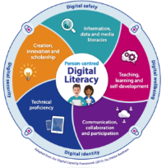

Li

Programs offered

* Robotics/ tinkering
* Computer hardware
* Cooking/hospitality
* Beauty & wellness
* Stitching& cutting
* Electrical troubleshooting
* Two-wheeler repairing
* Mobile journalism
* Computer science
* Call centre /BPO
* Logisties
* Data digitization
* Natural farming market connect
* Banking

WWW. LITERACY INDIA .Org Session Starts from

sSE **o**Sessin Starts From

Limtied Seats

lL

9810567496

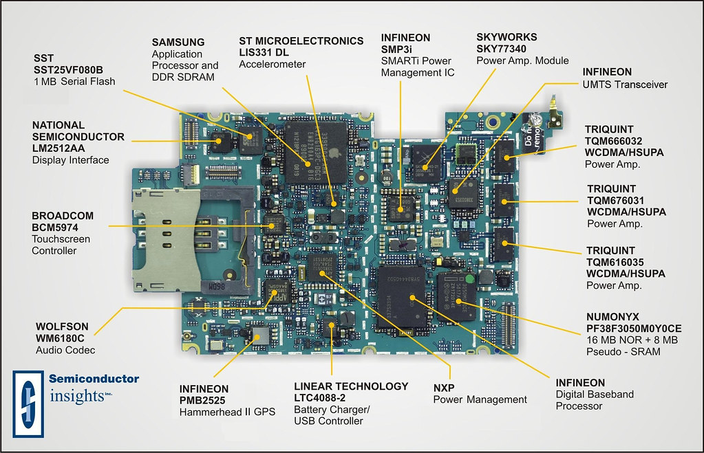

[This Photo](https://www.flickr.com/photos/inju/2671615966) by Unknown Author is licensed under [CC BY-SA-NC](https://creativecommons.org/licenses/by-nc-sa/3.0/)

LLL Literacy India Community college( LICC)

0

jbjh

jjjjjhhhugugujgujyggyh

LllLL

**www. Literacyindia.org**



**Register now**